Phone Number Verification

📱 What is Phone Number Verification?
# Source: AI Source: Provided by: [Data Path: Persons Table -> ID Column: 1, Name_En Column: Motasem Essam] -> From: [ChatGPT] on [1/18/2026]
Phone number verification is the process of confirming that a phone number belongs to a user and is reachable. It typically involves sending a code (OTP) via SMS or call, and asking the user to enter that code in your app or website.

🔹 Why Use Phone Number Verification?
# Source: AI Source: Provided by: [Data Path: Persons Table -> ID Column: 1, Name_En Column: Motasem Essam] -> From: [ChatGPT] on [1/18/2026]
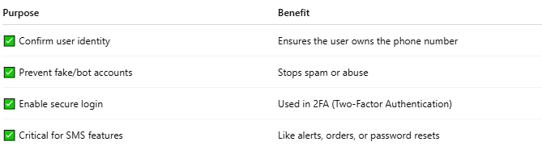

Purpose | Benefit
✅ Confirm user identity | Ensures the user owns the phone number
✅ Prevent fake/bot accounts | Stops spam or abuse
✅ Enable secure login | Used in 2FA (Two-Factor Authentication)
✅ Critical for SMS features | Like alerts, orders, or password resets

🔄 How Phone Verification Works
# Source: AI Source: Provided by: [Data Path: Persons Table -> ID Column: 1, Name_En Column: Motasem Essam] -> From: [ChatGPT] on [1/18/2026]
1. User enters phone number
2. System generates a random code (e.g. 123456)
3. Code is sent via SMS or call
4. User enters code in your app/site
5. System matches the code and marks the number as verified

🔐 Code (OTP) Example
# Source: AI Source: Provided by: [Data Path: Persons Table -> ID Column: 1, Name_En Column: Motasem Essam] -> From: [ChatGPT] on [1/18/2026]
- SMS content:
"Your verification code is 983245. It will expire in 10 minutes."

🔧 Services That Provide Phone Number Verification
# Source: AI Source: Provided by: [Data Path: Persons Table -> ID Column: 1, Name_En Column: Motasem Essam] -> From: [ChatGPT] on [1/18/2026]
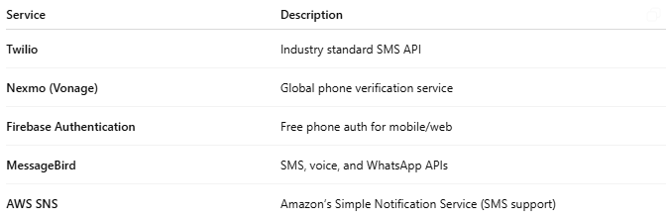

Service | Description
Twilio | Industry standard SMS API
Nexmo (Vonage) | Global phone verification service
Firebase Authentication | Free phone auth for mobile/web
MessageBird | SMS, voice, and WhatsApp APIs
AWS SNS | Amazon’s Simple Notification Service (SMS support)

🧪 Example with Firebase Phone Auth
# Source: AI Source: Provided by: [Data Path: Persons Table -> ID Column: 1, Name_En Column: Motasem Essam] -> From: [ChatGPT] on [1/18/2026]
- User inputs phone number
- Firebase sends SMS code
- User types the code
- Firebase checks and logs the user in

🛠️ Example Flow Using Twilio in PHP
# Source: AI Source: Provided by: [Data Path: Persons Table -> ID Column: 1, Name_En Column: Motasem Essam] -> From: [ChatGPT] on [1/18/2026]
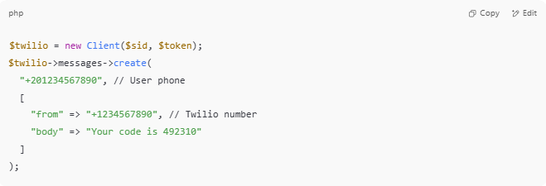

$twilio = new Client($sid, $token);
$twilio->messages->create(
"+201234567890", // User phone
[
"from" => "+1234567890", // Twilio number
"body" => "Your code is 492310"
]
);

🛡️ Used for:
# Source: AI Source: Provided by: [Data Path: Persons Table -> ID Column: 1, Name_En Column: Motasem Essam] -> From: [ChatGPT] on [1/18/2026]
- ✅ Sign up / Login
- 🔑 2FA security
- 📦 Order tracking updates
- 🔁 Password reset
- 🤖 Spam prevention

